**VISVESVARAYA TECHNOLOGICAL UNIVERSITY**

**“Jnana Sangama”, Belgaum -590014, Karnataka.**



**PROJECT WORK-1 REPORT**

**on**

**PROJECT TITLE**

***Submitted by***

**SUDESHNA BHUSHAN (1BM19CS189)**

**DYUTHI ABHITHA PRAKASH(1BM19CS196)**

**NANDITA MAHENDRA (1BM19CS203)**

**RUBIANA JOSEPHINE PAUL (1BM19CS208)**

***Under the Guidance of***

|  |  |
| --- | --- |
| **Rekha G S**  **Assistant Professor, BMSCE** |  |

***in partial fulfilment for the award of the degree of***

**BACHELOR OF ENGINEERING**

***in***

**COMPUTER SCIENCE AND ENGINEERING**



**B.M.S. COLLEGE OF ENGINEERING**

**(Autonomous Institution under VTU)**

**BENGALURU-560019**

**Sep-2020 to Jan-2021**

**B. M. S. College of Engineering,**

**Bull Temple Road, Bangalore 560019**

(Affiliated To Visvesvaraya Technological University, Belgaum)

**Department of Computer Science and Engineering**



**CERTIFICATE**

This is to certify that the project work entitled “**PROJECT TITLE**” carried out by **SUDESHNA BHUSHNA(1BM19CS189), DYUTHI ABHITHA PRAKASH (1BM19CS196), NANDITA MAHENDRA(1BM19CS203) AND RUBIANA JOSEPHINE PAUL (1BM19CS208)** who are bonafide students of

**B. M. S. College of Engineering.** It is in partial fulfilment for the award of **Bachelor of Engineering in Computer Science and Engineering** of the Visvesvaraya Technological University, Belgaum during the year 2020-2021. The project report has been approved as it satisfies the academic requirements in respect of **Project Work-1 (1a9CS3PWPW1)** work prescribed for the said degree.

Signature of the Guide                 Signature of the HOD

Rekha G S Dr. Umadevi V

Assistant Professor Associate Prof.& Head, Dept. of CSE

BMSCE, Bengaluru BMSCE, Bengaluru

External Viva

Name of the Examiner                                                                                       Signature with date

1._____________________________ ________________________

2. _____________________________ _________________________

**B.M.S. College of EngineerinG**

**DEPARTMENT OF COMPUTER SCIENCE AND ENGINEERING**



***DECALARATION***

We, SUDESHNA BHUSHAN (1BM19CS189), DYUTHI ABHITHA PRAKASH (1BM19CS196), NANDITA MAHENDRA (1BM19CS203), RUBIANA JOSEPHINE PAUL (1BM19CS208), students of 3rd Semester, B.E, Department of Computer Science and Engineering, B. M. S. College of Engineering, Bangalore, hereby declare that, this Project Work-1entitled "Project Title" has been carried out by us under the guidance of Rekha G S, Assistant Professor, Department of CSE, B. M. S. College of Engineering, Bangalore during the academic semester Sep-2020-Jan-2021.

We also declare that to the best of our knowledge and belief, the development reported here is not from part of any other report by any other students.

Signature

SUDESHNA BHUSHAN (1BM19CS189)

DYUTHI ABHITHA PRAKASH (1BM19CS196)

NANDITA MAHENDRA (1BM19CS203)

RUBIANA JOSEPHINE PAUL (1BM19CS208)

Introduction

Website development for “CAKERY”

This online cakery system supports following users

a. entrepreneurs

b. public

**Functionalities under user information login**

1.Public users can login by entering their personal information

2.it is available in both light and dark mode

2. Design Layouts: Screen Shots of Webpages

LOGIN WEBPAGE

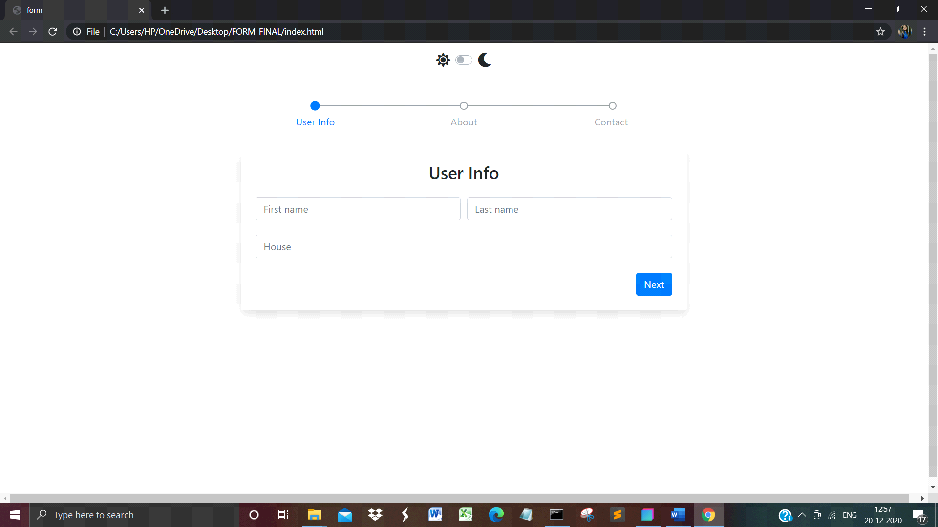

**Fig.1 Login Screen in light mode**

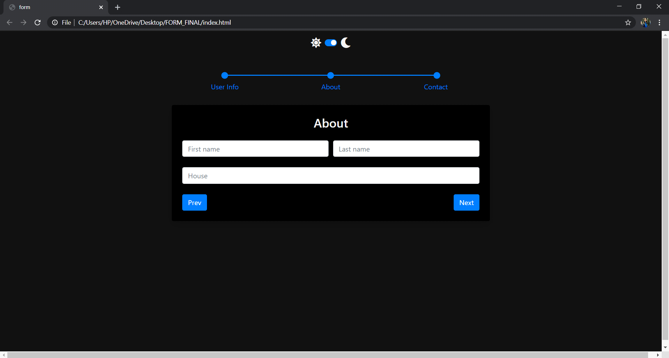

**Fig2. Login Screen in dark mode**

HOME WEBPAGE

1.The home page has information about the current offers which are available

2.The chefs of the bakery

3.The different types of cake and cake designs available

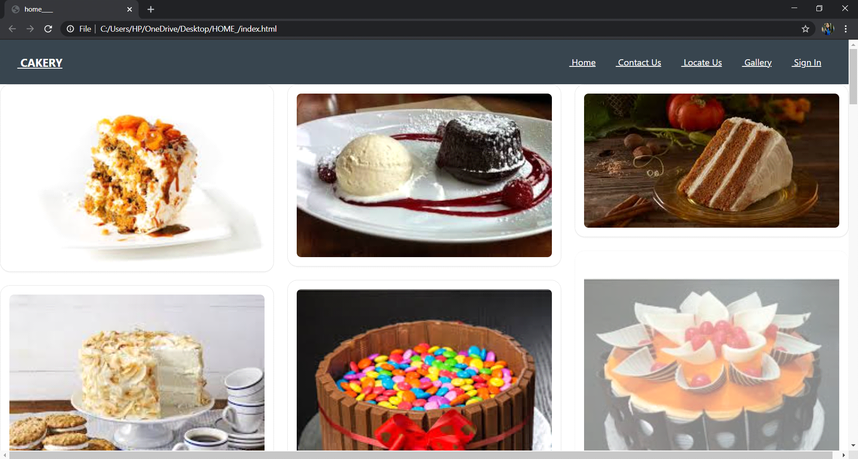

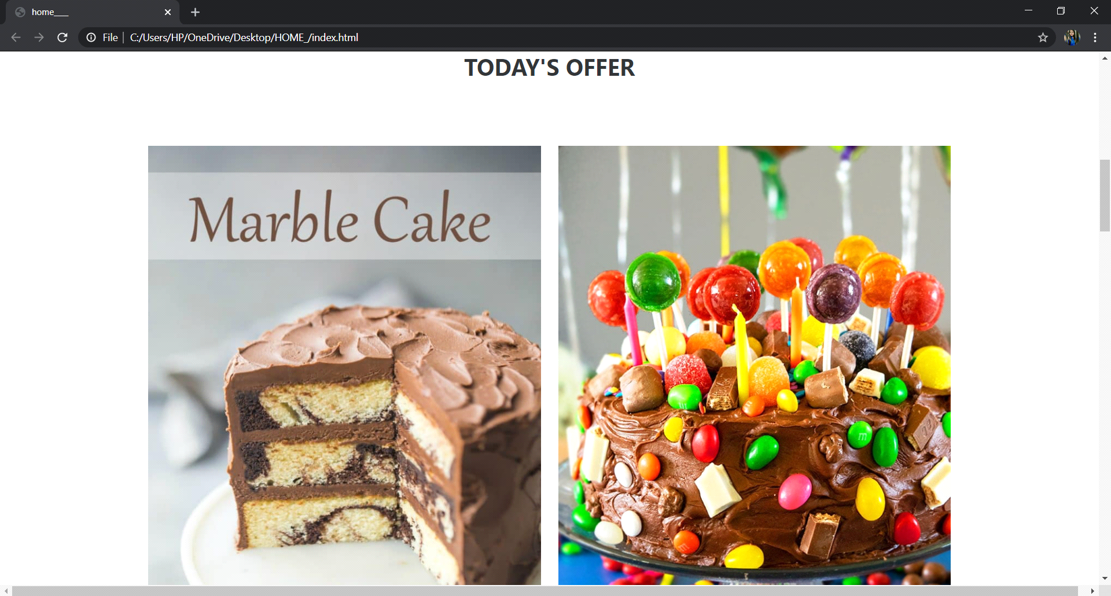

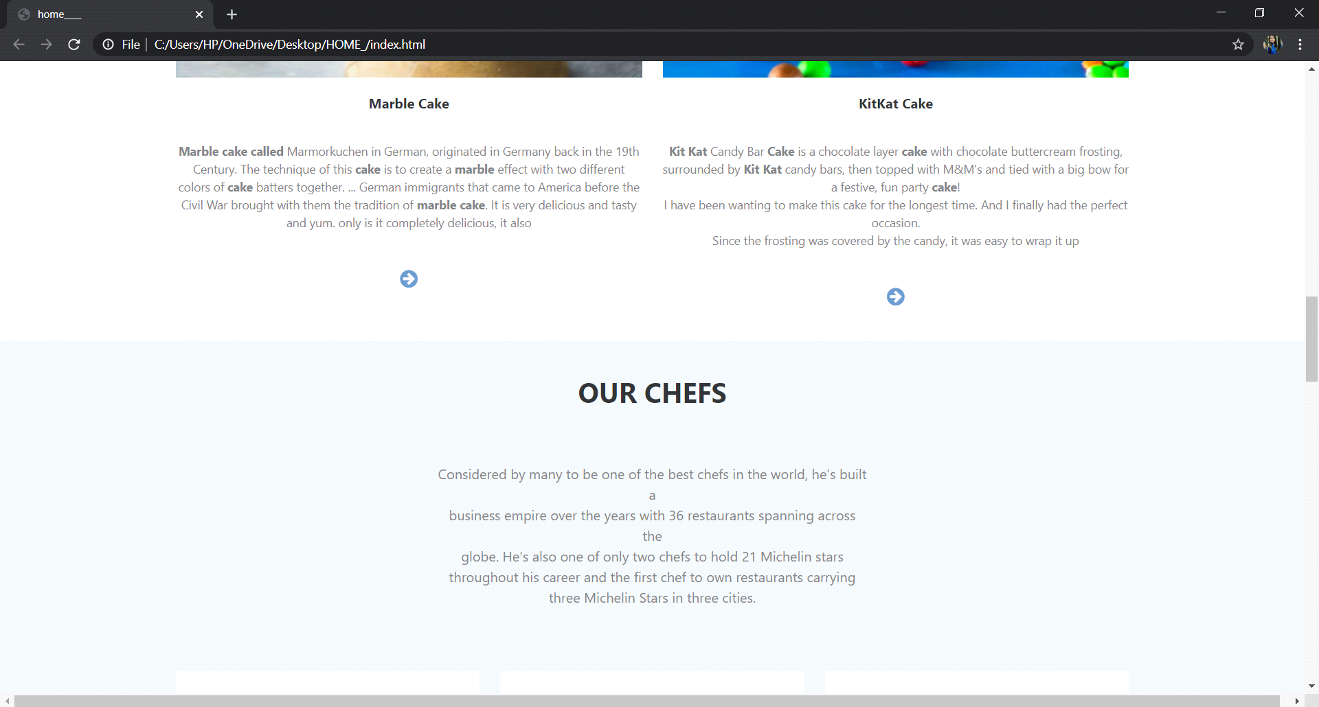

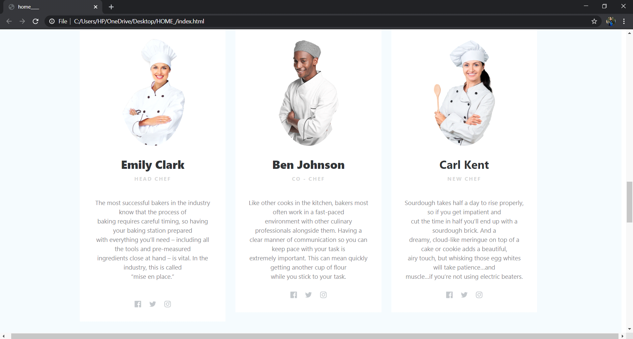

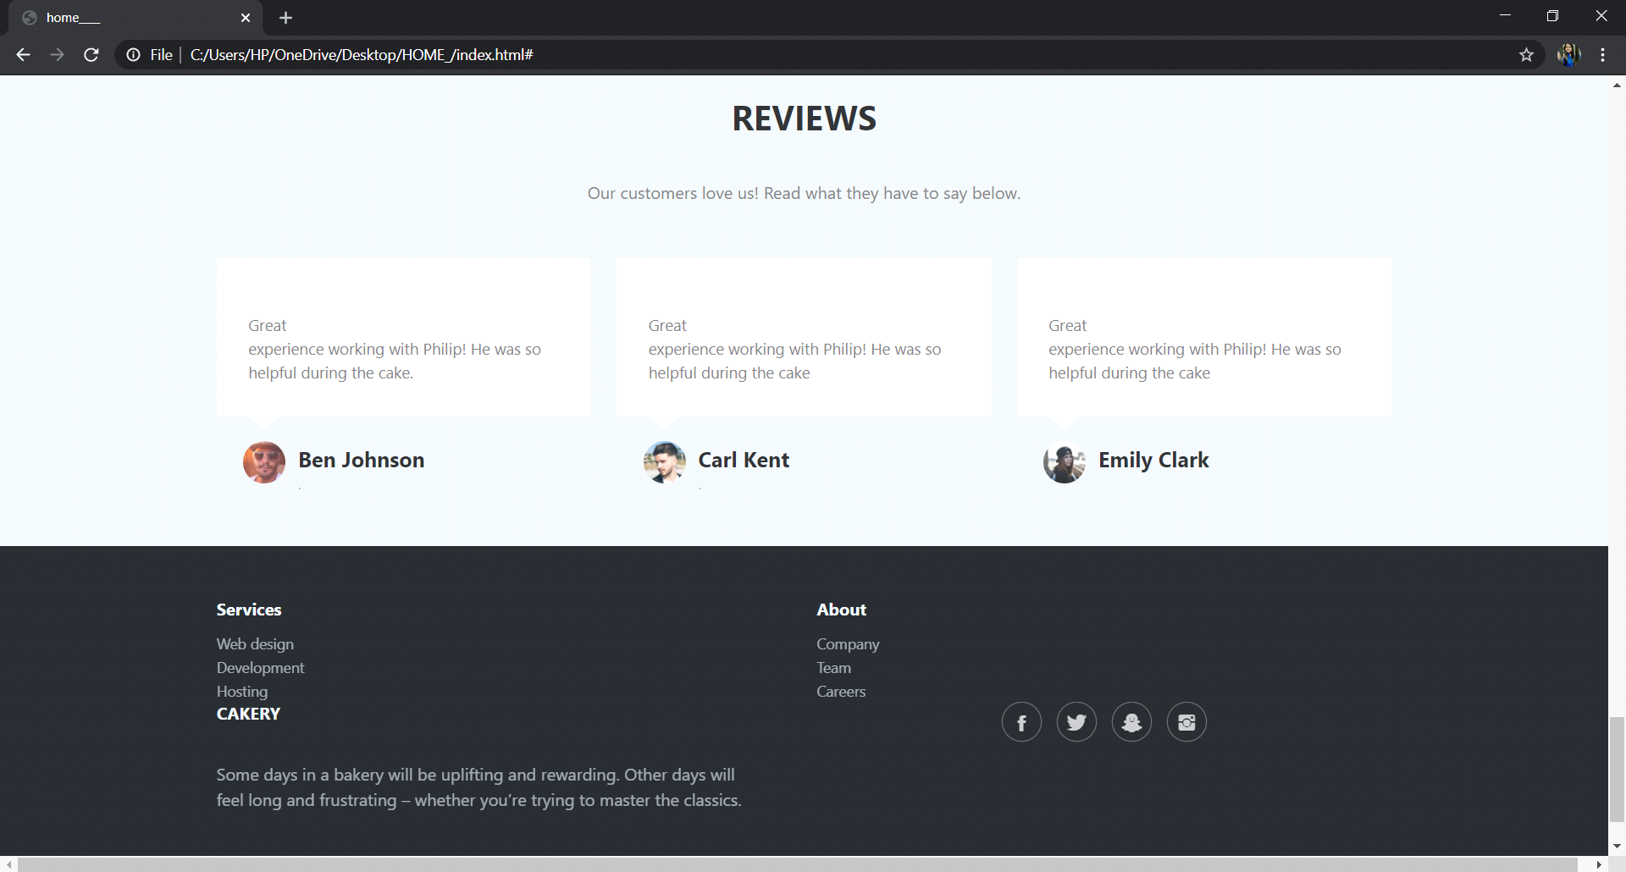

LOCATE US PAGE

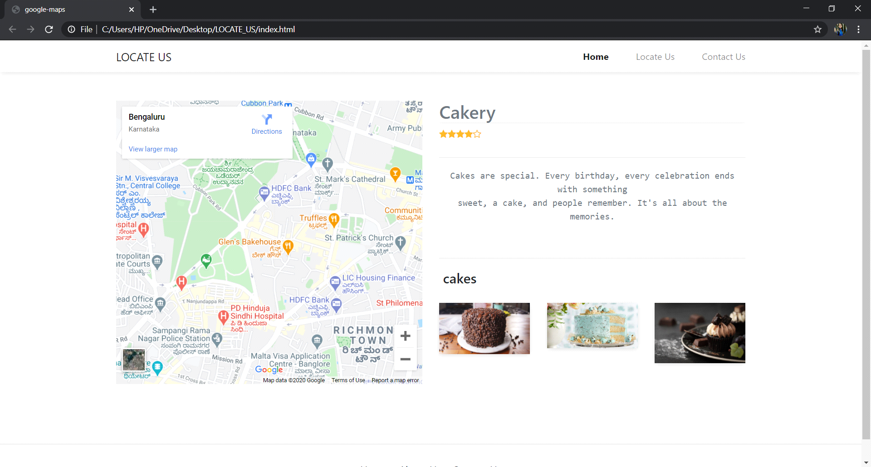

**Fig.3 Locate us page**

GALLERY

1.Images of the baked or cooked items

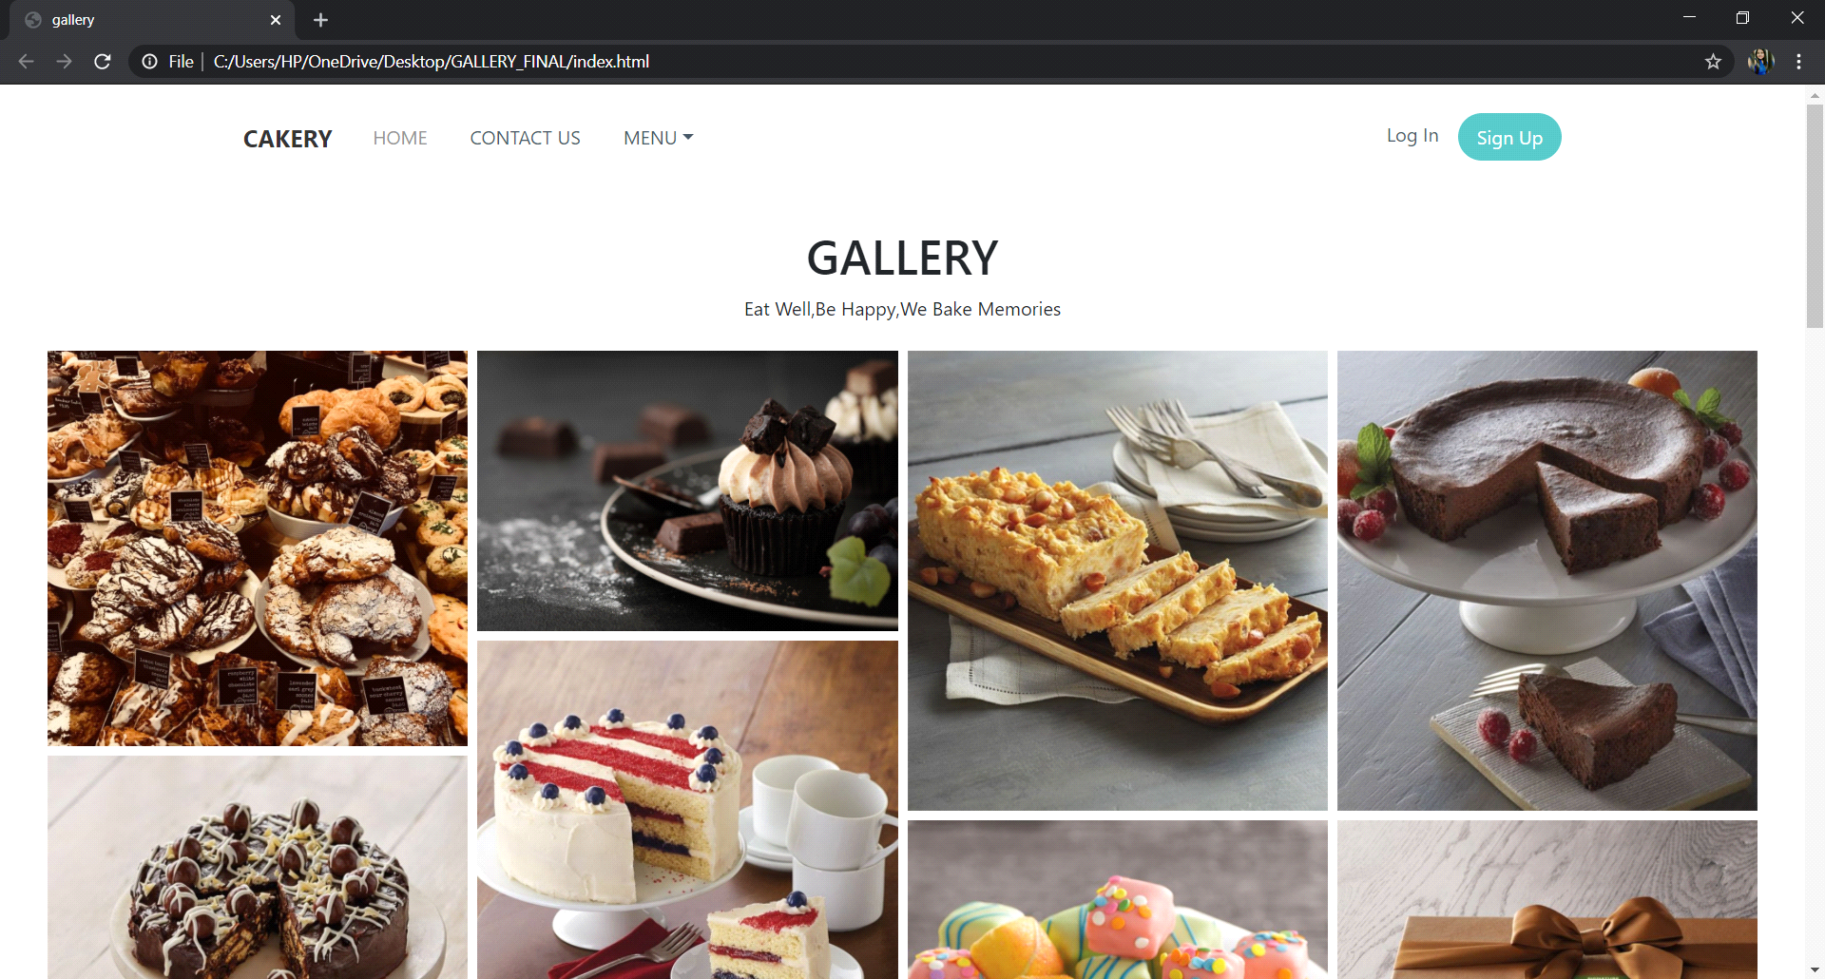

**Fig.4 gallery**

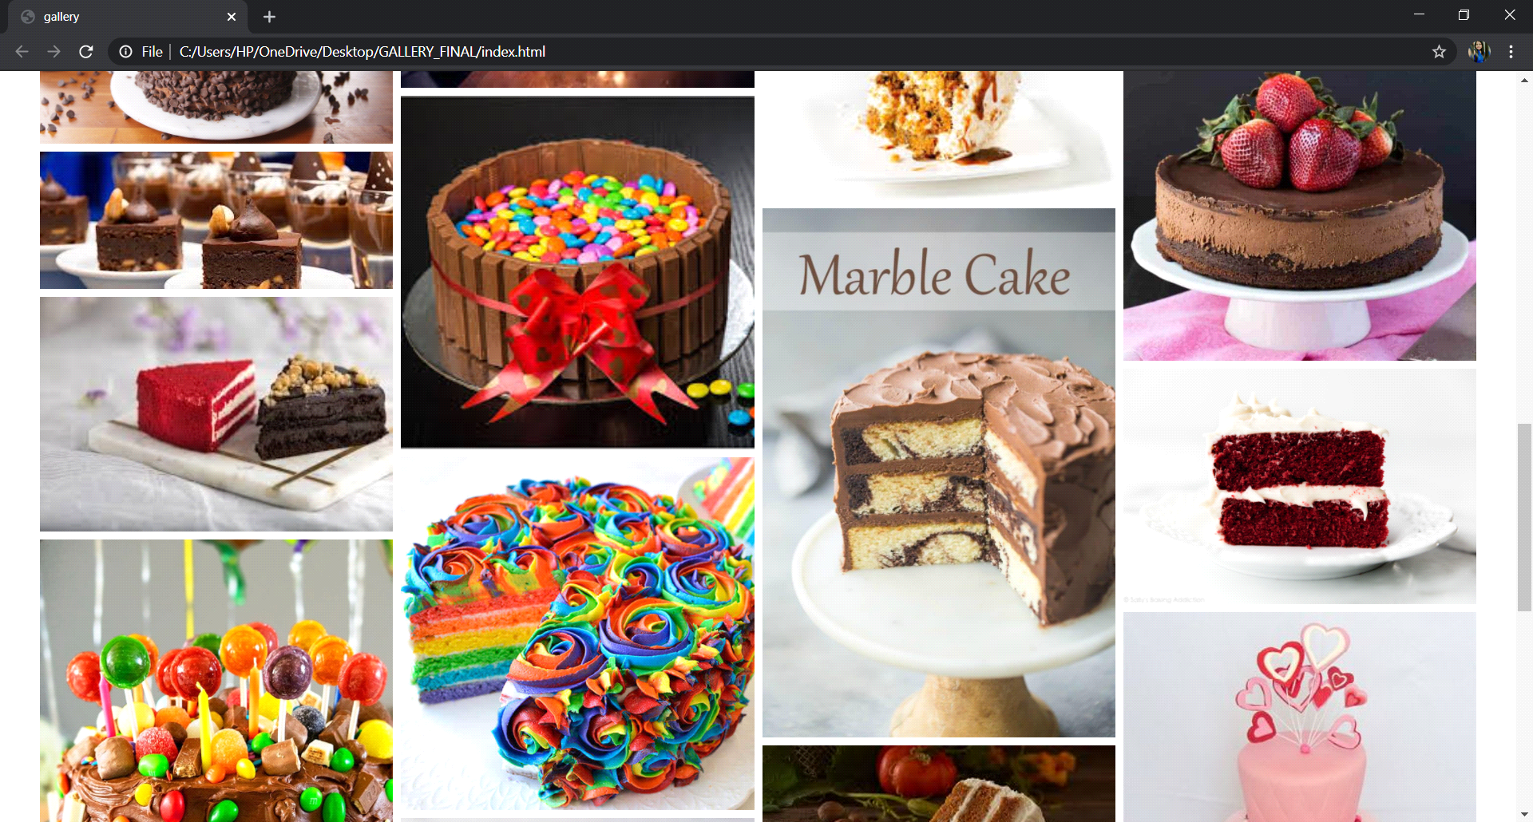

**Fig.5 gallery**

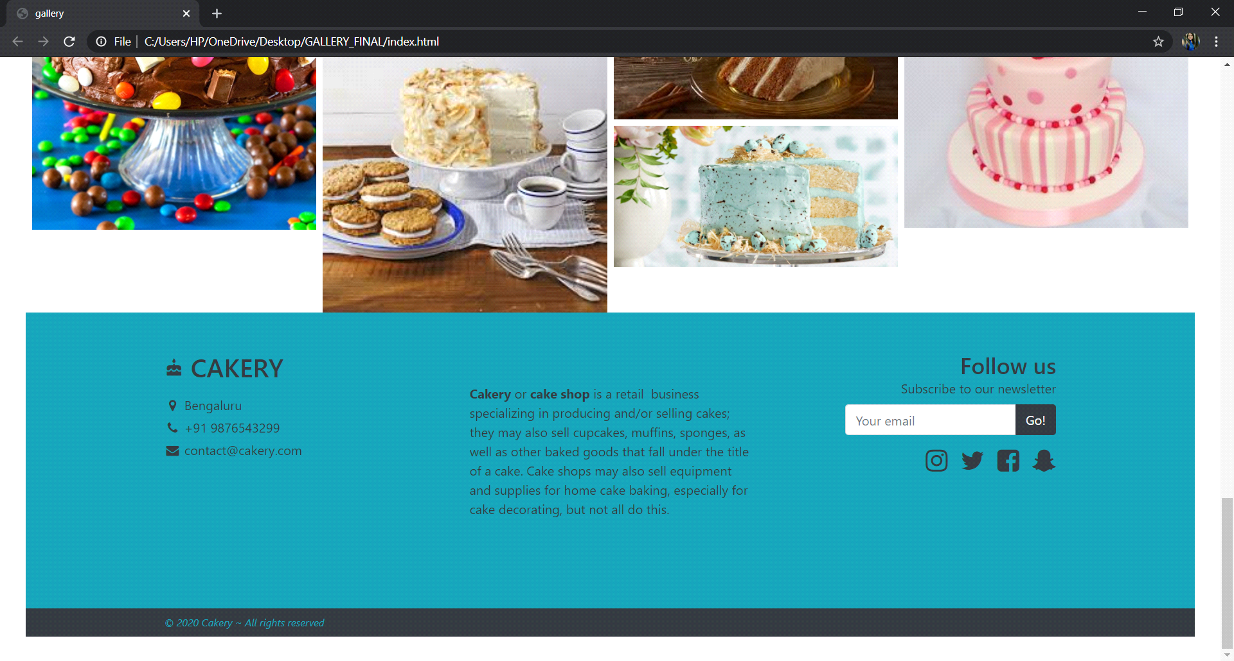

**Fig.6 gallery**

PAYMENT PAGE

1.This page is for payment purposes

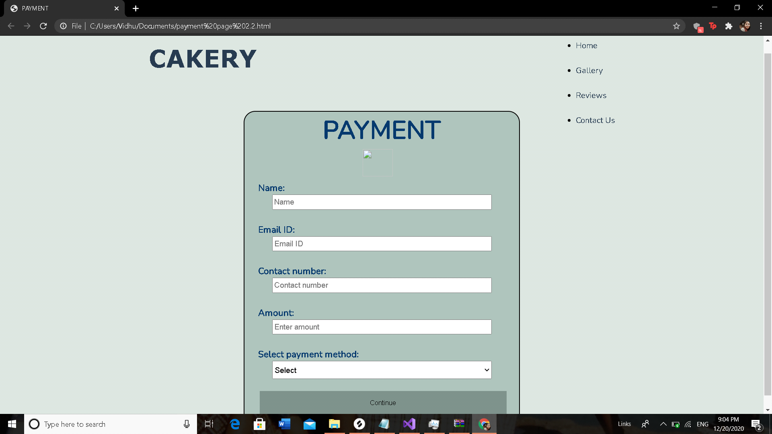

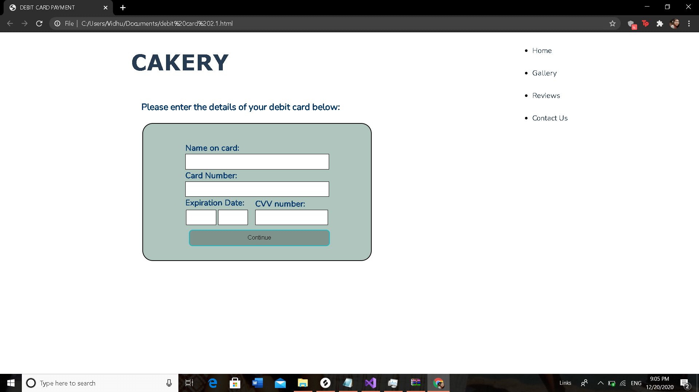

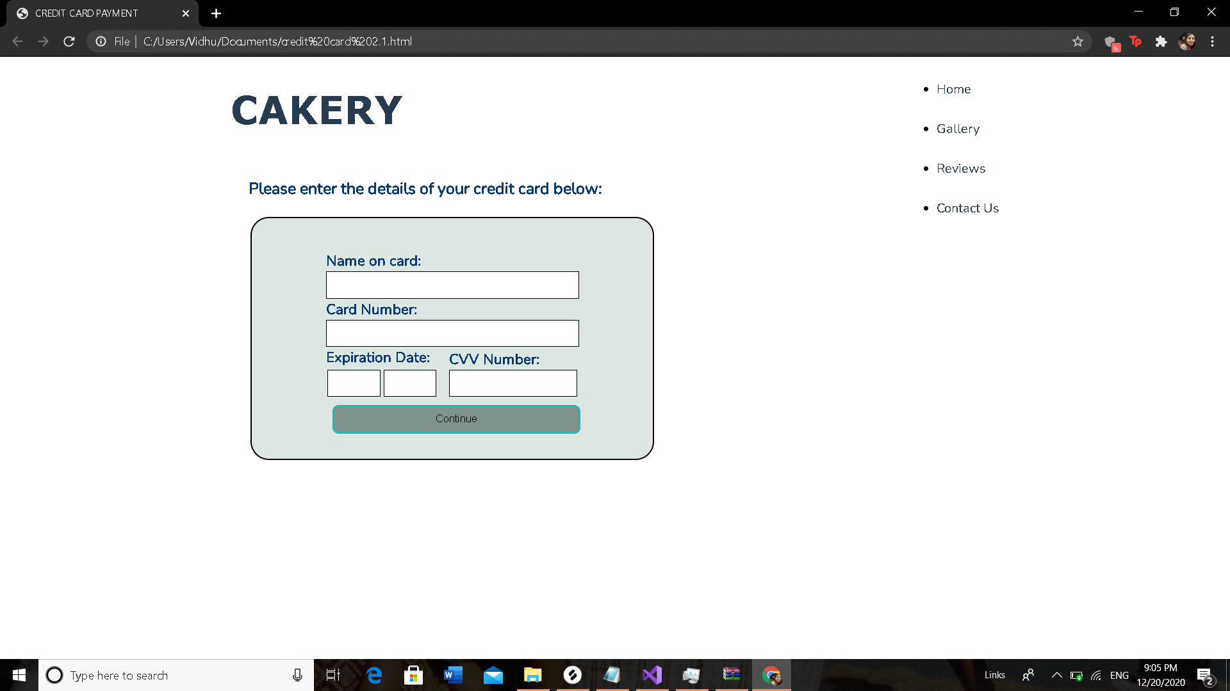

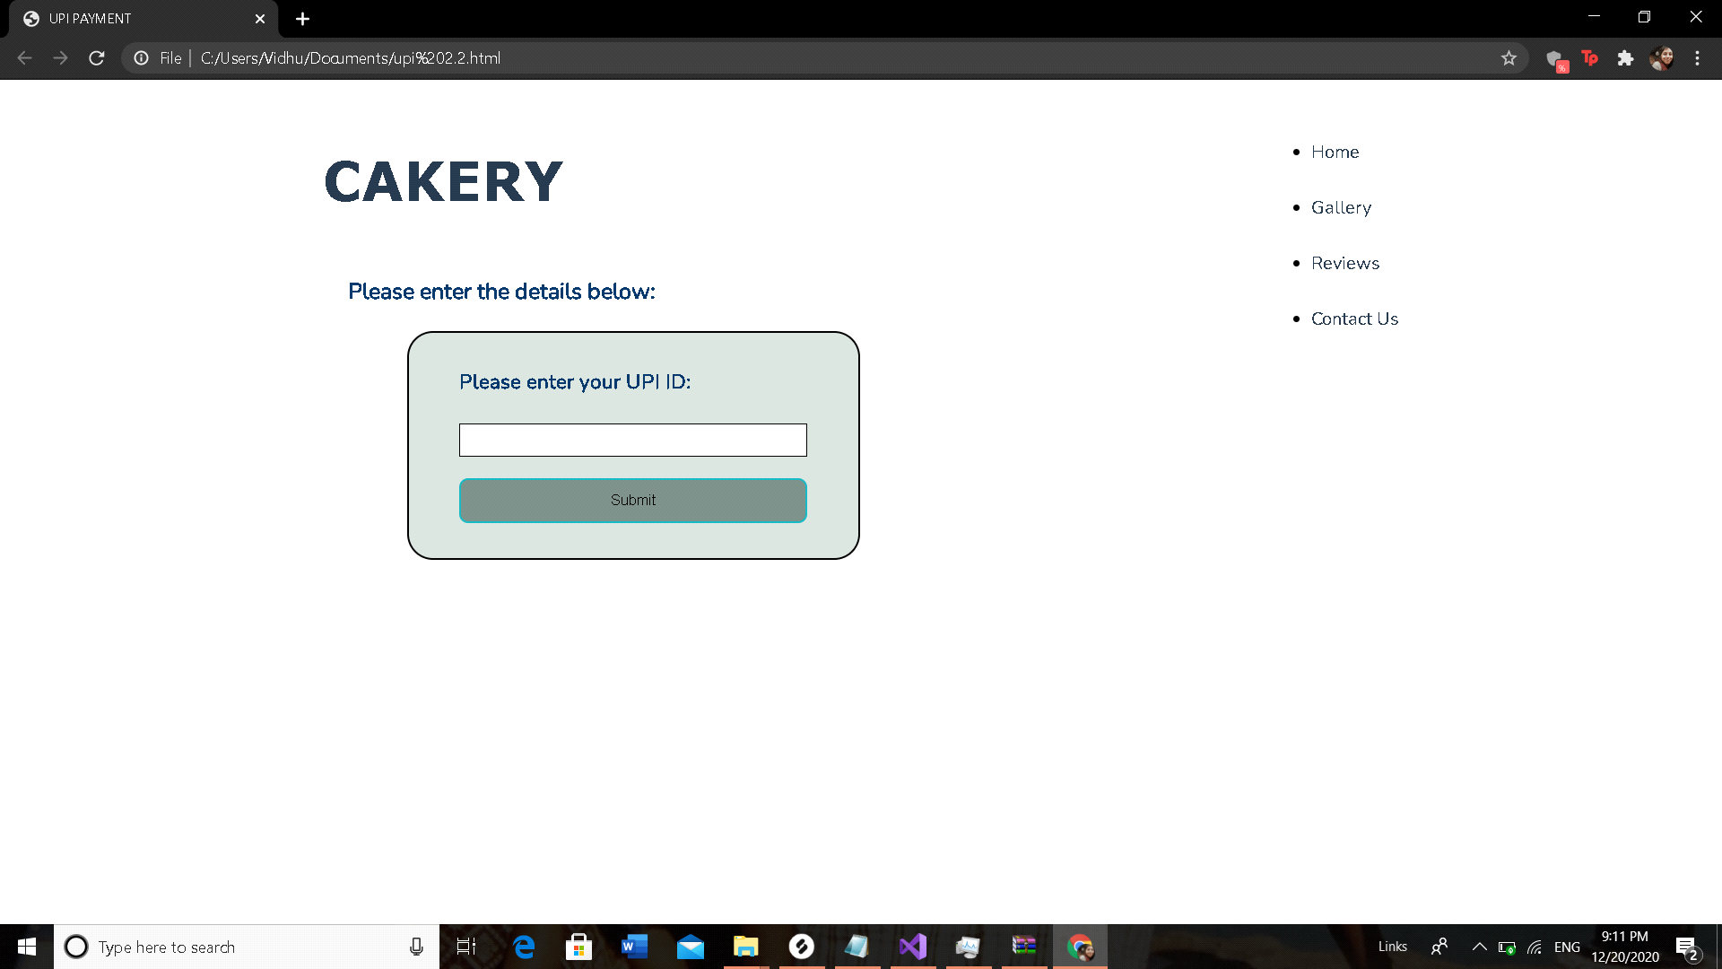

REVIEWS

1. Users can give their review on this page

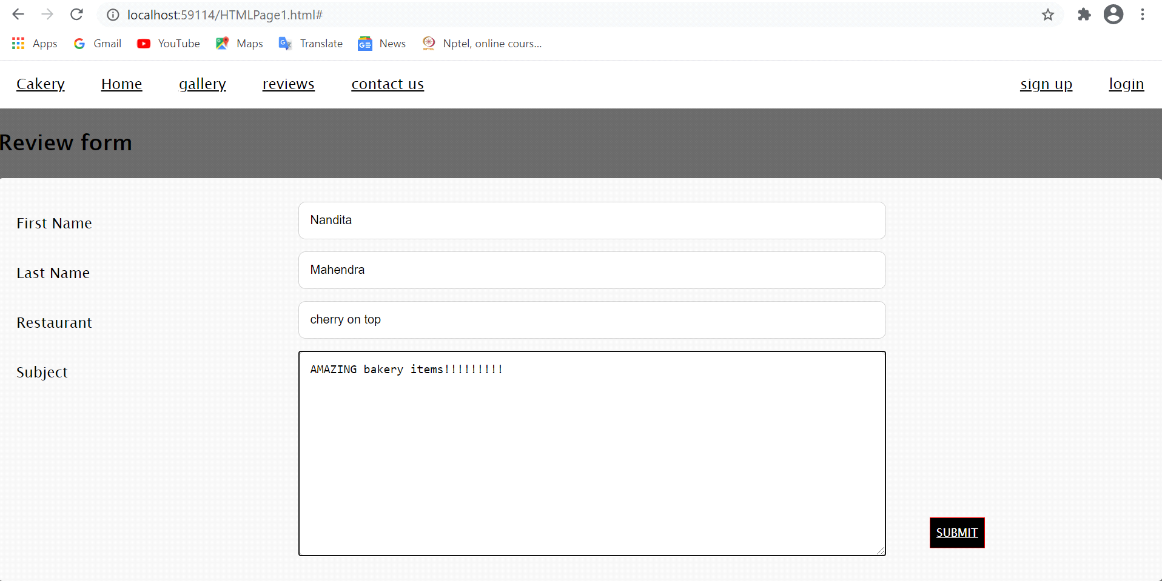

2.Response of the review page

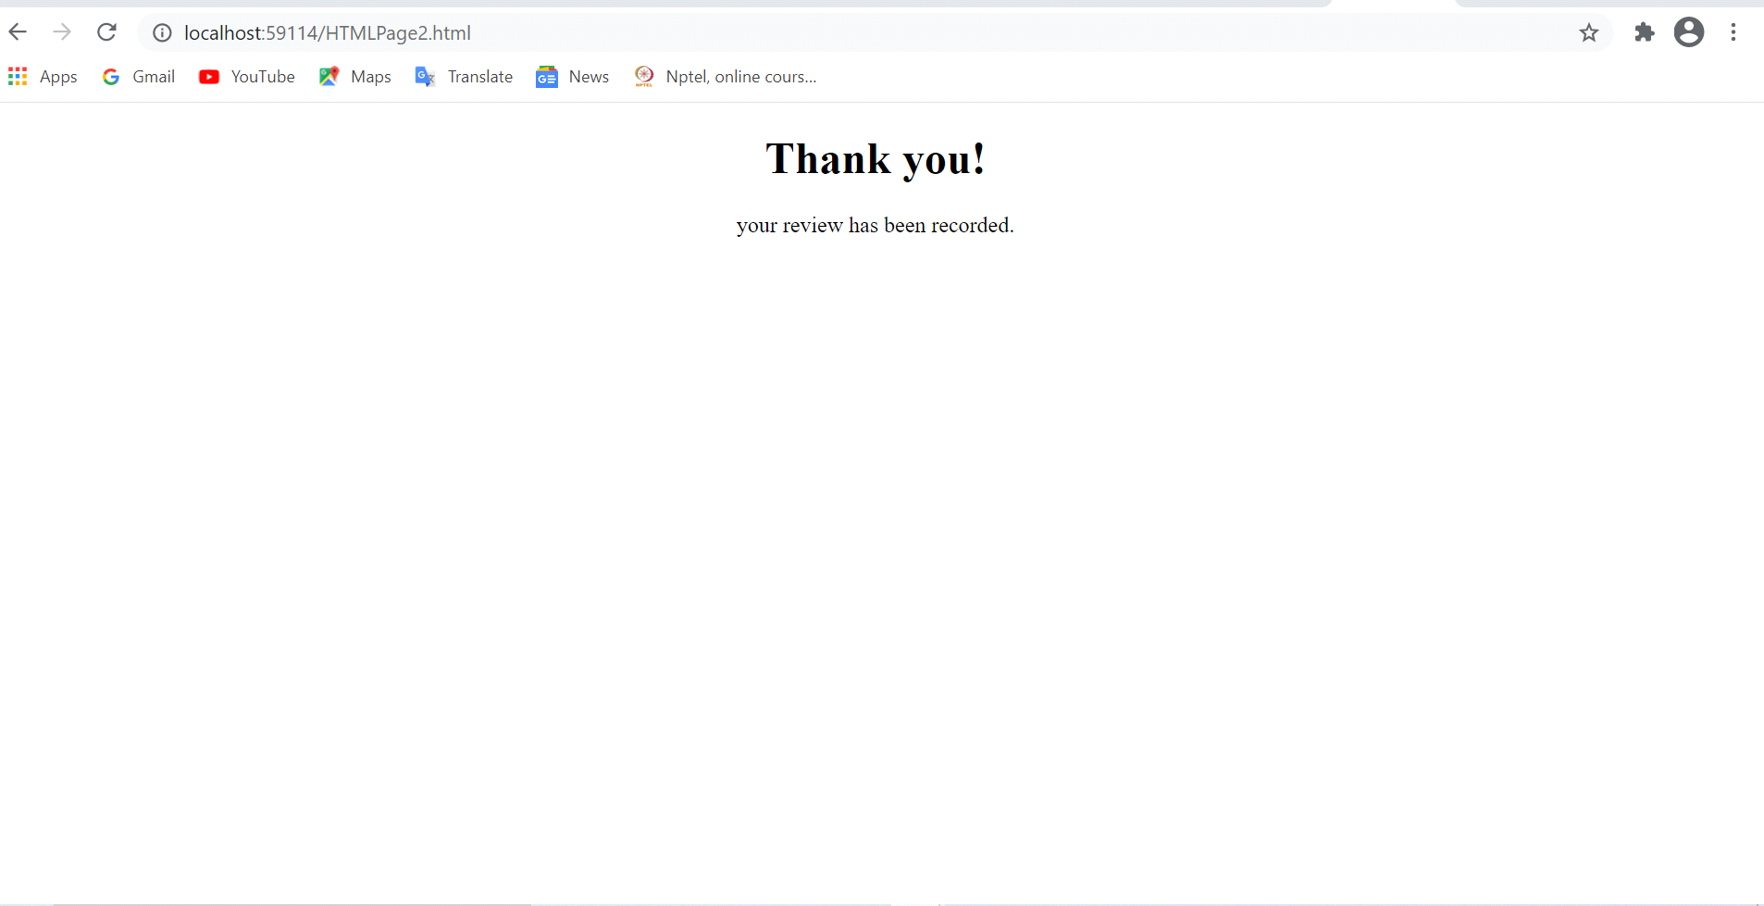

CONTACT US PAGE

**1.**In case of any queries the customer can contact the bakery

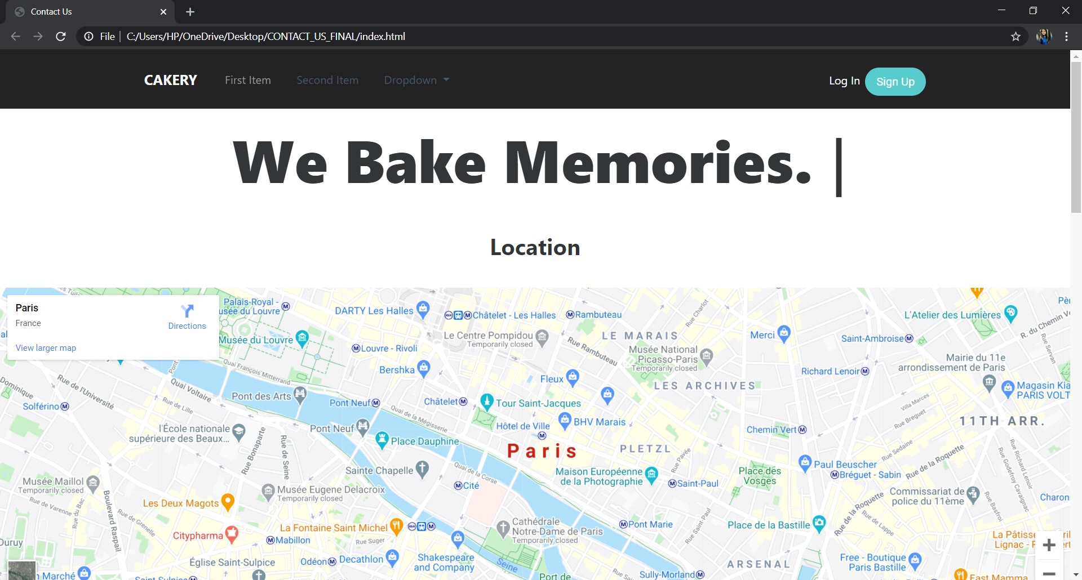

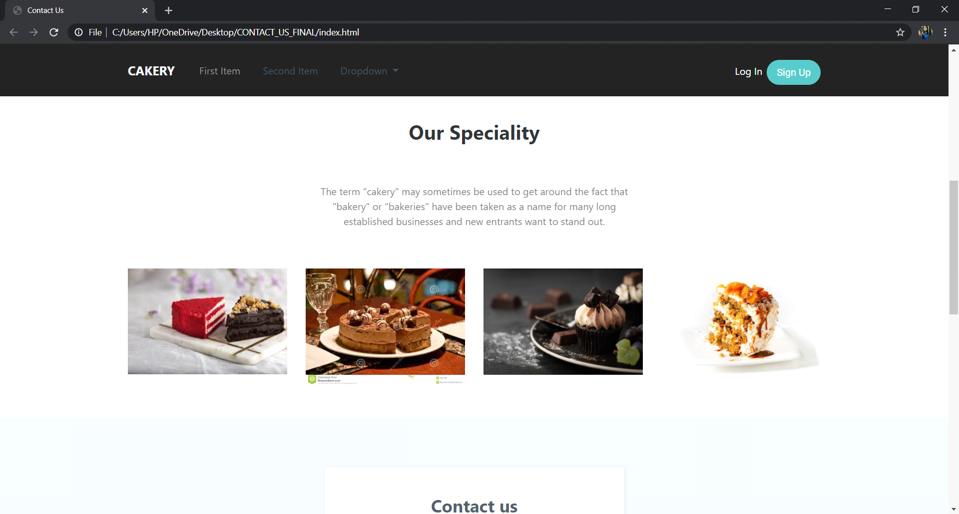

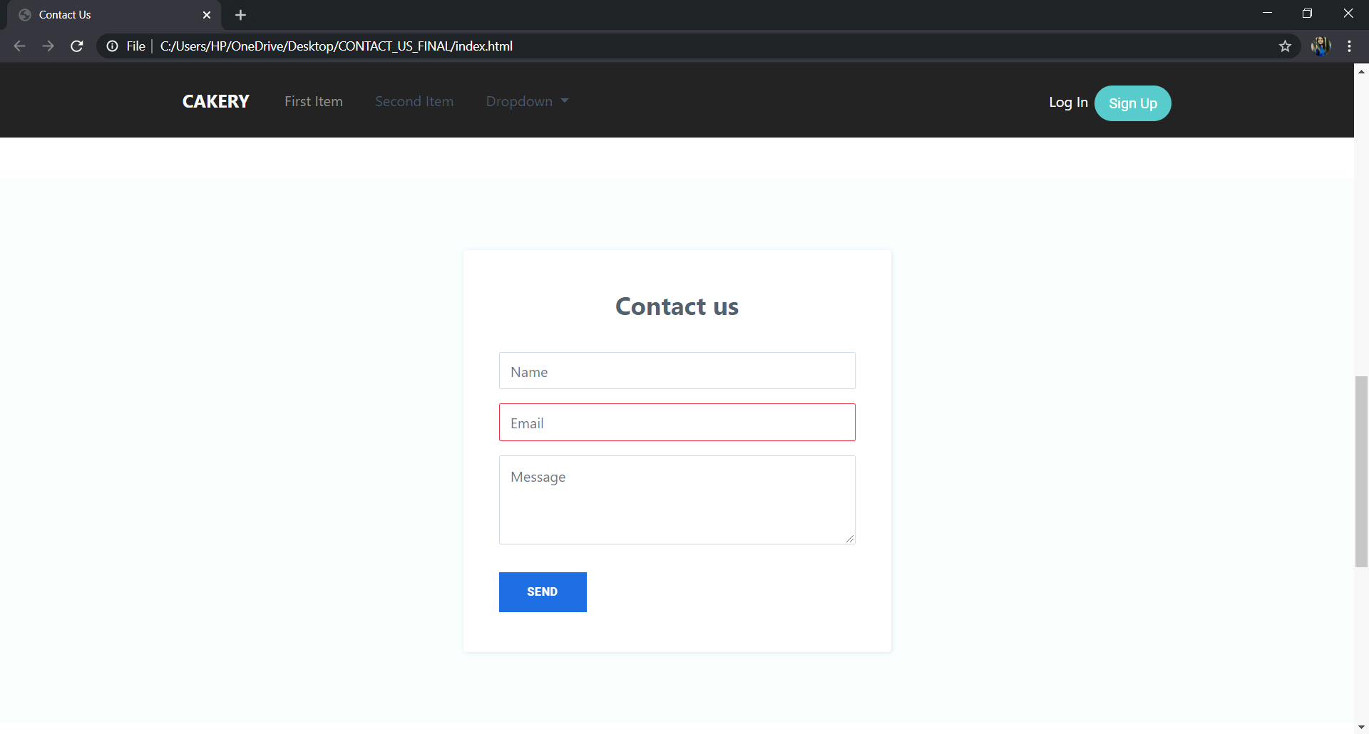

2.If the customer has registered to the website they will get daily updates and also can access the newsletter

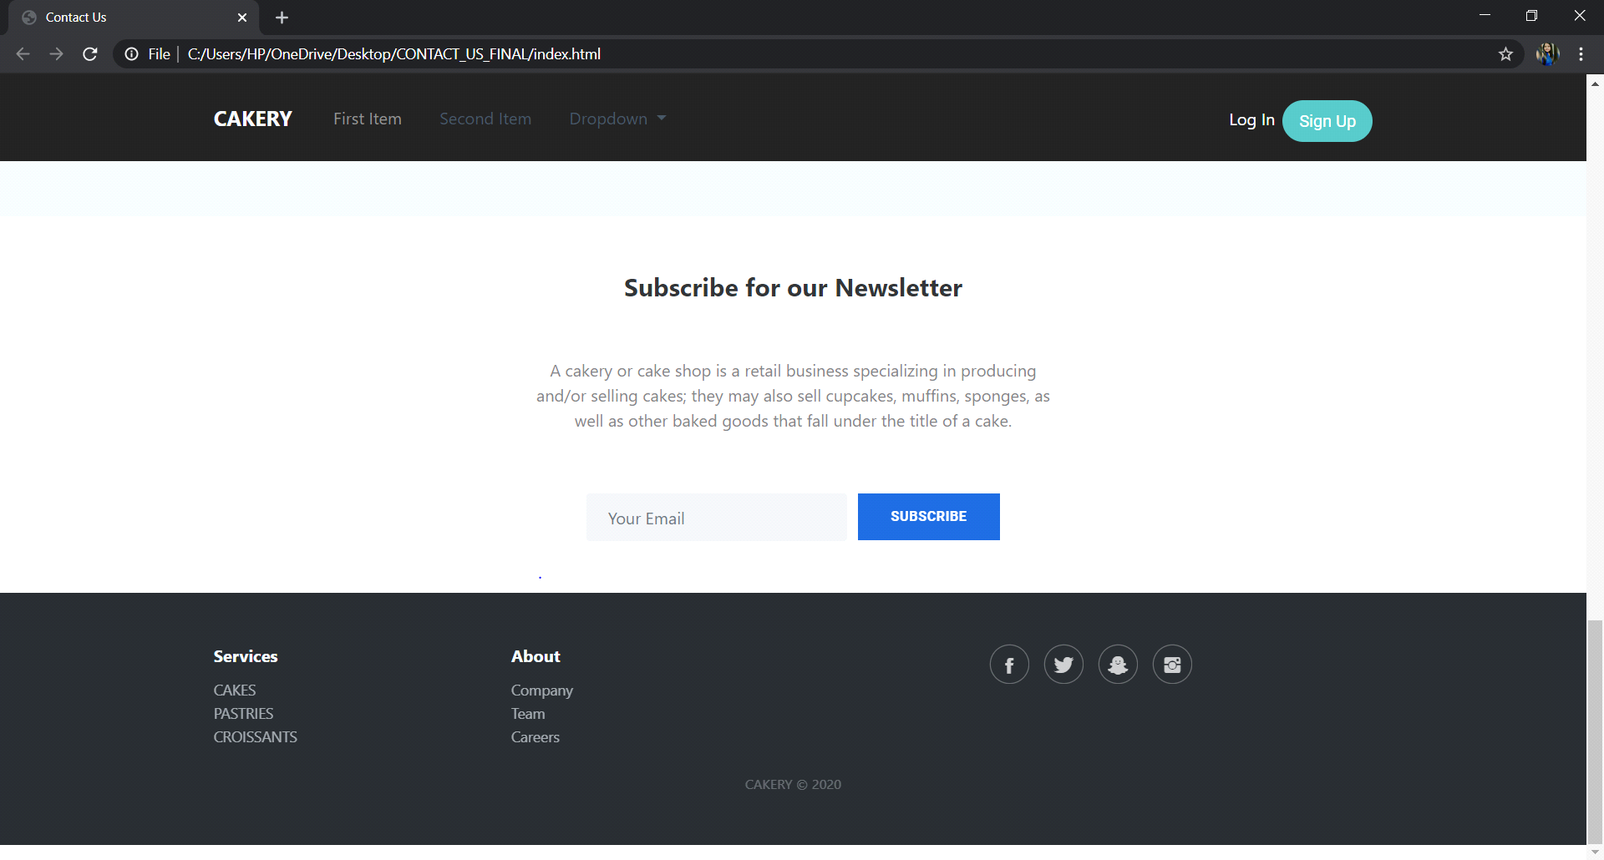

BUSINESS PAGE

This page supports local business.

